1.Spring-data-jpa-handson

## **HandsOn 1**

### **Spring Data JPA - Quick Example**

**Creating database :**

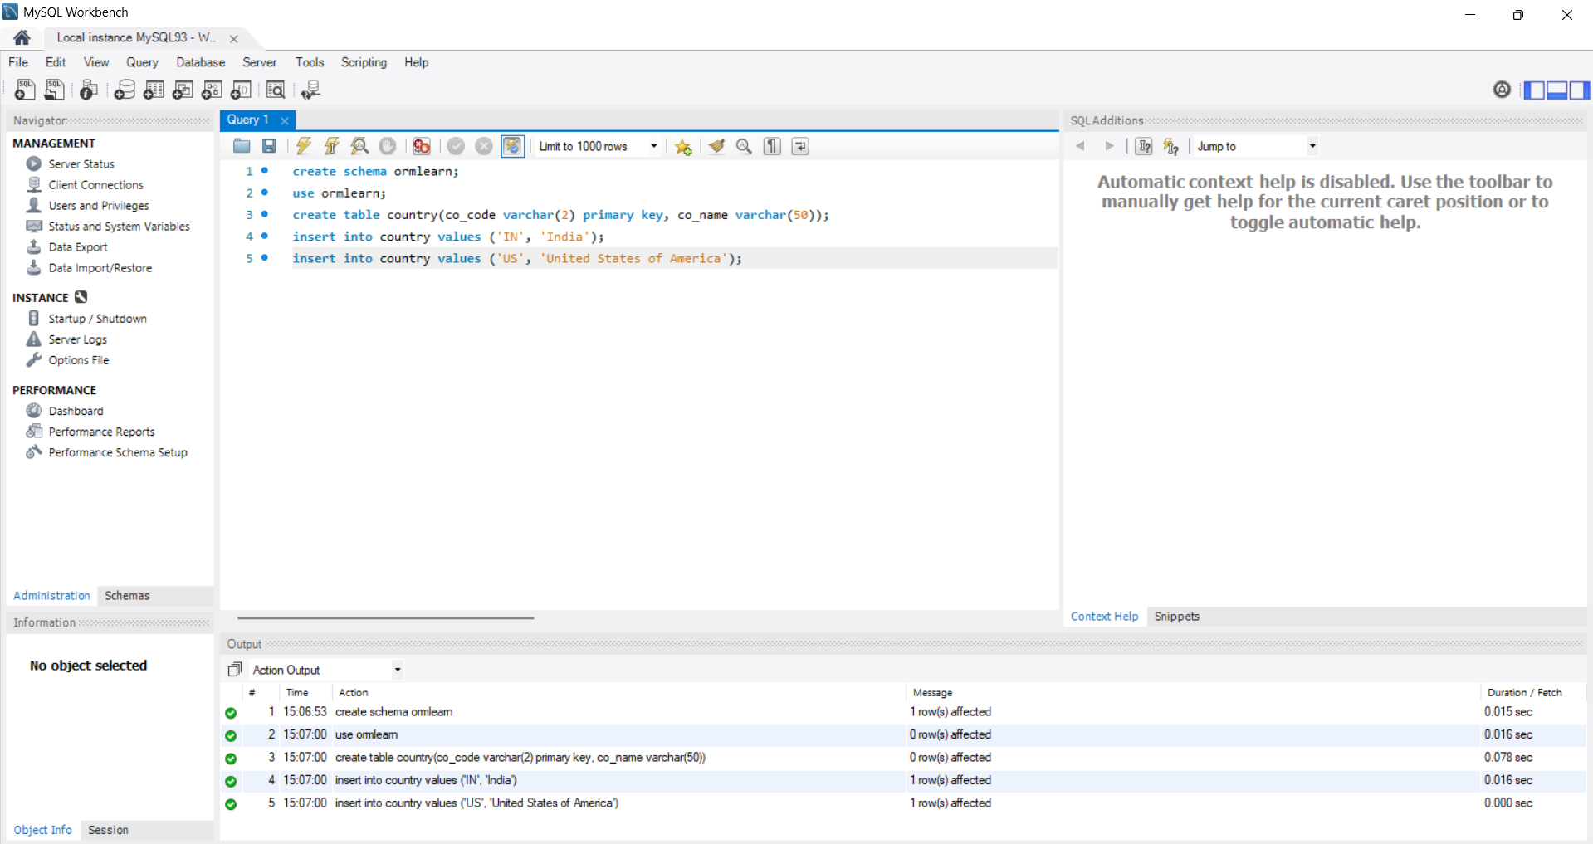

CREATE schema ormlearn;

use ormlearn;

CREATE table country(co_code varchar(2) primary key, co_name varchar(50));

INSERT into country values ('IN', 'India');

INSERT into country values ('US', 'United States of America');

**Creating Project in Spring Initializr :**

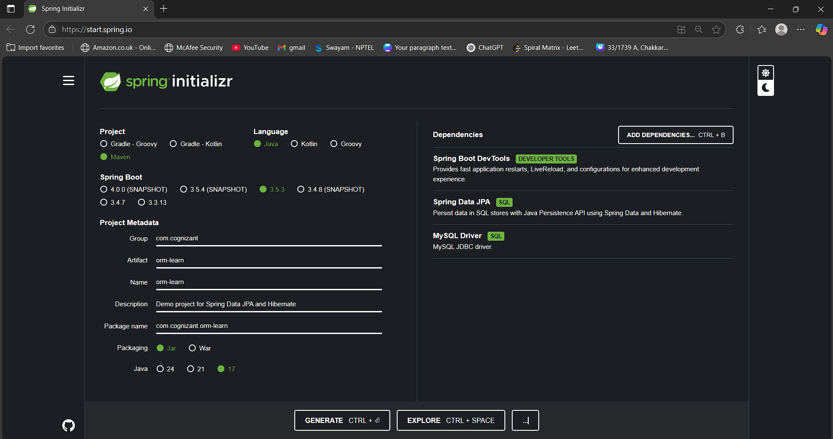

**Logging**

logging.level.org.springframework=info logging.level.com.cognizant=debug logging.level.org.hibernate.SQL=trace logging.level.org.hibernate.type.descriptor.sql=trace

**Log pattern**

logging.pattern.console=%d{dd-MM-yy} %d{HH:mm:ss.SSS} %-20.20thread %5p %-25.25logger{25} %25M %4L %m%n

**Database connection**

spring.datasource.driver-class-name=com.mysql.cj.jdbc.Driver spring.datasource.url=jdbc:mysql://localhost:3306/ormlearn spring.datasource.username=root spring.datasource.password=root

**Hibernate**

spring.jpa.hibernate.ddl-auto=validate spring.jpa.properties.hibernate.dialect=org.hibernate.dialect.MySQL5Dialect

**Country.java:**

package com.cognizant.ormlearn.model;

import javax.persistence.*;

@Entity

@Table(name = "country")

public class Country {

@Id

@Column(name = "co_code")

private String code;

@Column(name = "co_name")

private String name;

// Getters & Setters

public String getCode() { return code; }

public void setCode(String code) { this.code = code; }

public String getName() { return name; }

public void setName(String name) { this.name = name; }

@Override

public String toString() {

return "Country [code=" + code + ", name=" + name + "]";

}

}

**CountryRepository.java:**

package com.cognizant.ormlearn.repository;

import org.springframework.data.jpa.repository.JpaRepository;

import org.springframework.stereotype.Repository;

import com.cognizant.ormlearn.model.Country;

@Repository

public interface CountryRepository extends JpaRepository<Country, String> {

**}**

**CountryService.java:**

package com.cognizant.ormlearn.service;

import java.util.List;

import javax.transaction.Transactional;

import org.springframework.beans.factory.annotation.Autowired;

import org.springframework.stereotype.Service;

import com.cognizant.ormlearn.model.Country;

import com.cognizant.ormlearn.repository.CountryRepository;

@Service

public class CountryService {

@Autowired

private CountryRepository countryRepository;

@Transactional

public List<Country> getAllCountries() {

return countryRepository.findAll();

}

}

**OrmLearnApplication.java** :

package com.cognizant.ormlearn;

import java.util.List;

import org.slf4j.Logger;

import org.slf4j.LoggerFactory;

import org.springframework.boot.SpringApplication;

import org.springframework.boot.autoconfigure.SpringBootApplication;

import org.springframework.context.ApplicationContext;

import com.cognizant.ormlearn.model.Country;

import com.cognizant.ormlearn.service.CountryService;

@SpringBootApplication

public class OrmLearnApplication {

private static final Logger LOGGER = LoggerFactory.getLogger(OrmLearnApplication.class);

private static CountryService countryService;

public static void main(String[] args) {

ApplicationContext context = SpringApplication.run(OrmLearnApplication.class, args);

countryService = context.getBean(CountryService.class);

testGetAllCountries();

}

private static void testGetAllCountries() {

LOGGER.info("Start");

List<Country> countries = countryService.getAllCountries();

LOGGER.debug("countries={}", countries);

LOGGER.info("End");

}

}

**OUTPUT:**

